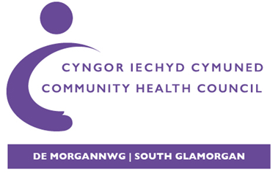

Cyngor Iechyd Cymuned De Morgannwg
Canolfan Fusnes Pro Copy (Cefn)
Parc Tŷ Glas
Llanishen, Caerdydd
CF14 5DU

South Glamorgan Community Health Council
Pro Copy Business Centre (Rear)
Parc Tŷ Glas
Llanishen, Cardiff
CF14 5DU

GP Scrutiny Programme – Patient Survey Links

English Survey Link: https://forms.office.com/Pages/ResponsePage.aspx?id=uChWuyjjgkCoVkM8ntyPrk5lKGiPBDVCnwi5lHVs0PtUMVJPSjdORDZaQ0xKV05HSENPWkFMMFo5RCQlQCN0PWcu

Welsh Survey Link: https://forms.office.com/Pages/ResponsePage.aspx?id=uChWuyjjgkCoVkM8ntyPrk5lKGiPBDVCnwi5lHVs0PtUMVJPSjdORDZaQ0xKV05HSENPWkFMMFo5RCQlQCN0PWcu&lang=cy-GB

Embedded Link for website.: <iframe width="640px" height= "480px" src= "https://forms.office.com/Pages/ResponsePage.aspx?id=uChWuyjjgkCoVkM8ntyPrk5lKGiPBDVCnwi5lHVs0PtUMVJPSjdORDZaQ0xKV05HSENPWkFMMFo5RCQlQCN0PWcu&embed=true" frameborder= "0" marginwidth= "0" marginheight= "0" style= "border: none; max-width:100%; max-height:100vh" allowfullscreen webkitallowfullscreen mozallowfullscreen msallowfullscreen> </iframe>

Yours Sincerely

Leigh Gallacher
Swyddog Gweinyddol / Administrative Officer
CIC De Morgannwg / South Glamorgan CHC
‘Eich Corff Gwarchod GIG Lleol’ / ‘Your Local NHS Watchdog’
E-bost / Email: leigh.gallacher@wales.nhs.uk

