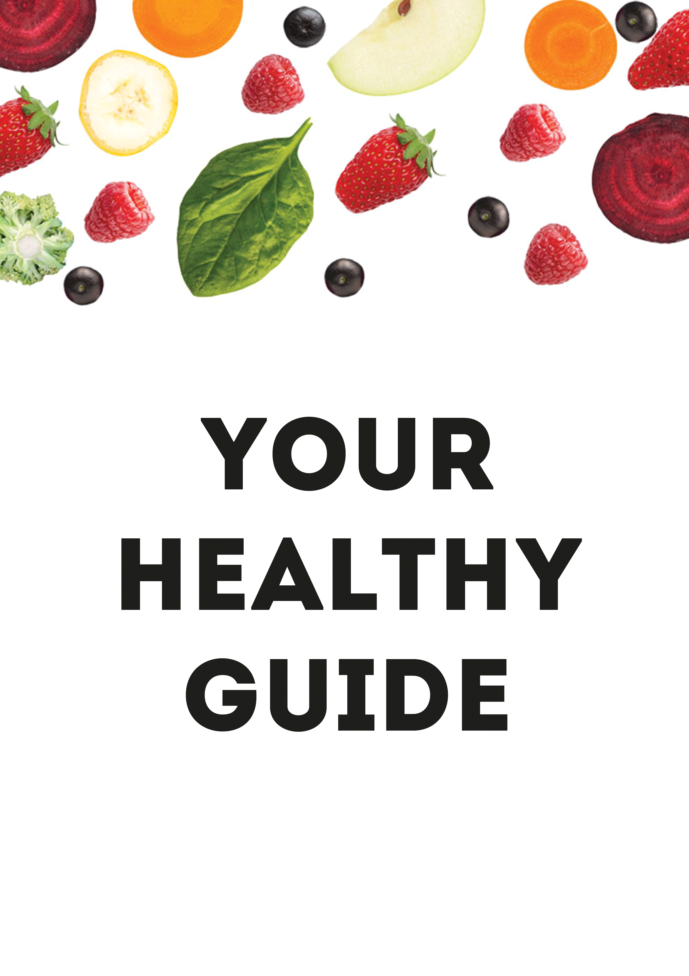
We live in an environment that makes it easy to become inactive, to gain weight and to feel bowed down by stress. We can’t do an awful lot to change that environment – but we can make lots of small changes to our own lives, little by little, day by day, that add up to a big difference. This is the 100 Ways pocket guide to getting healthier…

10 Take-homes
Even if you don’t read all of this guide, here’s a short and sharp top ten to set you off in a healthy direction. You don’t have to tackle all of these areas at once, but they will all enhance each other. Take it one step at a time and you may be surprised what happens:
- Base your diet on whole foods – including wholegrains and lots of veg and fruit.
- Cut back on sugar (all types), white flour (all types) and the foods made from them
- Nurture your gut. Try including some fermented foods in your diet.
- Reduce your alcohol intake.
- Watch your portion sizes.
- Focus on your food. Try eating more slowly and more thoughtfully, without distractions.
- Move. Any kind of activity or exercise is good.
- Take time for yourself. This is not indulgence: it is essential.
- Have a plan. Set simple goals and write down how you’ll achieve them. And if you don’t achieve all those goals, forgive yourself!
- Get support, give support. We’re in this together.

EAT MORE WHOLE FOODS, ESPECIALLY VEG, FRUIT AND WHOLEGRAINS

Health experts agree that it’s good for us to build our diets around healthy whole foods. If you focus on this key piece of advice – before you even think about calories or fat or carbs – your diet should automatically improve.

Whole foods are what our bodies have evolved to digest. They’re what we’re supposed to eat. They offer vitamins, minerals, antioxidants and fibre - and most whole foods give you a range of such nutrients. Whole foods can’t be replicated with supplements or vitamin pills.

A ‘whole food’ is simply an ingredient in its most natural, un-mucked-about form. Fresh veg, fruit, grains, pulses, herbs and spices, plain dairy products, eggs, unprocessed meat and fish – all these are great whole foods.

Sources of fat, such as olive oil, rapeseed oil, butter, avocados and nut butters can also be part of a healthy wholefood diet. Don’t fear fat: our bodies need it. Use it in moderate amounts to help make healthy foods delicious and satisfying.

How do you know if it’s a whole food?
When you’re deciding whether or not to put something in your shopping basket, ask yourself: what has been done to the raw ingredient in order to produce this? If it’s a whole food like a potato, an egg or a fresh chicken, the answer is going to be ‘not much at all’. If, on the other hand, you’re looking at some frozen hash browns, a packaged muffin or some chicken nuggets, the answer is ‘quite a lot’, i.e. it’s not very ‘whole’.

Another nifty trick (which we’ve nabbed from food writer Michael Pollan) is to ask “would my grandmother have recognised this?”. In the case of, say, ready meals, toaster ‘tarts’ or energy drinks, the answer is likely to be ‘no’, and that’s a sign that it’s definitely not a whole food!

Some simple whole food swaps
- Instead of a sugary breakfast cereal… Try jumbo oats or oatmeal – either cooked as porridge or soaked overnight with grated apple and orange juice.
- Instead of a sugary breakfast bar... Try a couple of hard-boiled eggs.
- Instead of jarred pasta sauce... Try roasted fresh cherry tomatoes. Toss them with oil and a little salt and pepper, then roast in a hot oven for around 20 minutes until they burst and release their juices.
- Instead of a curry ready-meal… Try a trayful of chunky chopped veg (say, sweet potato, cauliflower and red onions) tossed with curry paste and roasted, then served with a spoonful of plain yoghurt.
- Instead of chocolate biscuits... Try whole walnuts or almonds, eaten with a square of 70%-plus dark chocolate.

Eat lots of veg and fruit
Veg and fruit are the ultimate whole foods and loading your plate with them is the simplest way to overhaul your diet. They give us vitamins, minerals and ‘phytonutrients’ – protective plant chemicals. Diets rich in veg and fruit can reduce the risk of heart disease and stroke and are linked to a lower risk of some cancers.

The government’s advice to eat ‘five a day’ is great. But there’s no need to stop there! Aim to get fresh produce into every meal or snack you eat. It might seem like a challenge at first, but there are lots of ways to achieve it:

- Eat veg for breakfast. Try mushrooms on wholegrain toast or grated carrot in homemade muesli.
- Snack the rainbow. In between meals, snack on different coloured fruit and veg. There’s lots that can be almost ‘instant’: raw baby carrots, red, yellow or orange pepper sticks, cherry tomatoes, apple wedges, segments of clementine, avocado or kiwi fruit scooped straight out of the skin, grapes, bananas, berries, plums...
- Swap sandwiches for salads. Make up a big, hearty salad of greens, wholegrains, fruit and veg and it will do you for several lunchtimes - enhanced perhaps with nuts, a boiled egg, cold chicken or some tinned pulses.
- Make veg the heart of your evening meal, rather than a bit on the side. Try veggie curries, soups and bakes. If you make a meaty dish such as bolognese, pack it with loads of extra veg, plus beans or chickpeas.

Fibre
If you eat more whole foods and lots more fruit and veg, then you will automatically increase your fibre intake too. This is really important. Most people in the UK eat far less than the recommended 30g fibre a day. Fibre is essential to a healthy digestive system and it feeds our friendly gut bacteria – which can affect our health in many ways (see below). A low fibre intake has been associated with an increased risk of heart disease, diabetes, stroke, and breast and bowel cancers.

Here are a few extra ways to get more fibre into your life:
- Swap brown for white whenever you can; choose wholegrain breads, and brown rice and pasta.
- Use the 10:1 rule to work out if grain-based products, like breads, are a good source of fibre. Look on the ‘nutritional data’ panel - if it shows at least 1g of fibre for every 10g carbohydrate, you’re on to a good thing.
- Eat plenty of pulses, like beans, peas, lentils and chickpeas.
- Choose fresh fruit when you feel like a sweet snack, and whole nuts when you fancy a savoury one.
- Go for whole fruit and veg rather than juices, where most of the fibre is removed.

EAT LESS SUGAR AND WHITE FLOURS – A.K.A. REFINED CARBS

Another brilliant benefit of choosing whole foods, including plenty of fresh fruit and veg, is that there will be much less space left in your diet for refined carbohydrates. This is the term used to describe a group of ingredients - mostly sugars and white flours - that are the building blocks of most processed foods. On ingredient labels, when you see sugars, syrups and things that end in ‘-ose’, such as dextrose and maltose, as well as wheat flour, potato flour, rice flour and various starches, you can think of them all as refined carbs.

Refined carbs start out as natural ingredients like sugar beet or grains of wheat. But they then go through a complex series of processes – crushing, milling, filtering, sieving, heating etc. - that strip away their natural fibre and nutrients and reduce them to a fine powder. They end up as unnatural foods with little nutritional benefit beyond providing calories.

Refined carbs are absorbed by our bodies very quickly, sending our blood sugar levels up. These then quickly fall again, leaving us feeling hungry. Refined carbohydrate intake is increasingly linked to health problems such as weight gain, type 2 diabetes, and even heart disease.

Here’s how to cut back on refined carbs
- Eat more whole foods.
- Cut down on sweet treats, including chocolate, sweets, biscuits, cakes, pastries and puddings. Most of these are Refined Carb Central!
- Eat less bread, and better bread. Assuming you’re not intolerant to wheat, there’s nothing inherently wrong with bread, but don’t rely on it at every meal and try to choose wholegrain breads made with unrefined flours that will be digested more slowly by your body (see the 10:1 rule, above).
- Try reducing white pasta and rice and replacing them with whole grains like brown, black or red rice, pearl barley, pearled spelt, wholegrain bulgar wheat or quinoa.

LOOK AFTER YOUR GUT
Science is just beginning to uncover the amazing influence that our gut bacteria have on our health. Emerging evidence suggests that our ‘microbiome’ could affect everything from immunity to weight gain, diabetes and even depression. It’s such a new area that no one yet knows exactly which bacteria do what, but experts believe that the most sensible thing each of us can do to take care of our guts is to cultivate a diverse and varied population of bacteria.

The best way to achieve this is by eating a varied wholefood diet with lots of fibre, including plenty of veg, fruit and whole grains. If you cut down on sugary drinks, processed foods, artificial sweeteners and alcohol, you’ll also be doing your gut a massive favour.

But if you want to do more to nurture your gut, try eating some fermented foods. These are ‘probiotic’, which means they contain live, friendly bacteria that should enhance your existing gut population. These include:
- Live, ‘bio’ yoghurt (plain and unsweetened).
- Kefir (a yoghurt-like drink)
- Kombucha (a kind of fermented tea)
- ‘Live’ or ‘raw’ sauerkraut (fermented cabbage). Check that it is not pasteurised, as this will kill off beneficial bacteria.
- ‘Live’ or ‘raw’ kimchi (a spicier and more pungent kind of fermented cabbage)
- Any other ‘lacto-fermented’ vegetables.
- Miso – a fermented soya bean paste used in Japanese cooking. Again, an unpasteurised miso will still be ‘live’, and it’s most beneficial if you don’t heat it – try it in salad dressings.

Try some different types and brands of fermented foods, to see what you enjoy most. It’s best to start gradually, with fairly small quantities, as some people find they can initially unsettle the stomach.

DITCH SUGARY DRINKS
Sugar-sweetened beverages – or SSBs – include fizzy drinks, colas, sports drinks and energy drinks. But the term also covers squashes, fruit-flavoured drinks and fruit-flavoured ‘waters’. Together, these drinks are among the foremost sources of sugar in the modern diet. A standard can of cola contains around 35g sugar – that’s seven teaspoons - but even fruit-flavoured ‘sparkling spring water’ can have 20g.

Another part of the problem with SSBs is the very fact that they are drinks – liquids that we swallow fast, and in quantity. Generally speaking, the longer it takes something to pass through the digestive system, the more satisfying it is. But drinks, shoot through the system very fast. Your body isn’t able to register them in the same way it registers solid food. These drinks enable us to knock back hundreds of calories very quickly – and often we don’t even feel full.

Diet drinks aren’t a good swap. The sugar is replaced by flavourings and artificial sweeteners and there’s no good evidence these drinks help us maintain a healthy weight.

Tips:
- To wean yourself off, try diluting fizzy drinks with water – a little at first, then gradually more and more.
- Drink a glass of water before you go for a sugary drink – you’ll have less room for it and you’ll be less thirsty.
- Try a cup of tea or coffee instead – they will give you a boost without the sugar.

DIAL DOWN THE BOOZE
Most of us know that heavy drinking is incredibly damaging to our health. But even if you drink moderately, alcohol can be a real hindrance when you’re trying to be healthy. It’s full of calories, it’s dehydrating and it can disrupt sleep. It’s also very disinhibiting – after a drink we’re more likely to indulge in unhealthy food or to eat too much!

On a more serious level, alcohol, even at moderate levels, is linked to an increased risk of some types of cancer. And while some studies have associated moderate drinking with some benefits, particularly to do with heart health, you can have a very healthy heart without drinking a drop.

But for many of us, drinking alcohol remains one of life’s pleasures. It can help relaxation and social interaction and enhance our enjoyment of a meal. If you haven’t been told by your doctor to cut out alcohol, there are ways you can enjoy it as part of a healthy lifestyle:

- Stick to fewer than 14 units a week (and not all in one session!). In practice, that means less than a bottle and a half of wine, or six pints of beer.
- Have at least three alcohol-free days a week. It gives your system a break and helps to disrupt habitual drinking.
- Pour your own drink (friends can be over-generous). And finish your glass completely before considering another. It’s impossible to keep track of quantities if your glass is constantly being topped up.
- Don’t drink on an empty stomach – the alcohol will be absorbed more quickly, and you are also likely to eat more later on.
- Don’t stock up at home with lots of booze. Try only buying a little at a time. If it’s not in the house, you can’t drink it.
- Plan ahead for social occasions. Set yourself a drink limit before you go out, and try and stick to it. Make sure you have water to hand too and drink it alongside and in between any alcoholic drinks.
- Monitor your own drinking – there are various free apps you can download that will help you keep track the units of alcohol you’ve consumed, the calories they contain and the money they cost!
- Learn something about your own drinking behaviour. Do you feel you ‘need’ a drink when stressed? Do you use alcohol to help you relax? Is that glass of wine a reward for getting through the day? Whatever your motivation for drinking, find some healthy alternatives that you can turn to instead - at least some of the time. This is the first step towards ‘mindful drinking’, as opposed to mindless boozing.

EAT MODERATELY AND MINDFULLY

The size of a ‘regular’ portion has expanded in recent decades - whether that’s a ready meal, a fast food portion or a restaurant plateful. And many of us like to load up our plates at home too. Reducing portion sizes is one very simple way to help reduce our calorie intake. Here are some pointers:

- At home, use smaller bowls and plates. These are visual cues that can have a powerful effect on our subconscious.
- If you’re eating something that comes in a pack or tub, such as nuts, crisps or ice cream, portion it out into a small bowl.
- If you’re cooking rice or pasta, weigh them out first. 50-75g dry pasta or rice per person is plenty once it’s cooked
- When you’ve got the urge to pile more on to your plate, try saying to yourself ‘this will do for now, I can always eat more later if I want to’. You may well find that you don’t want to eat more later on, after all.
- One portion you should increase is your helping of veg: load up your plate with it and there will be less space for more calorific foods.
- Obey the 15 minute rule, leaving yourself quarter of an hour between a main course and anything else. It takes that long for your body to really register fullness – you might not want that sweet treat after all.
- Don’t assume that takeaway food presented as a single serving, such as a burger, pasty or carton of chips, is actually a sensible amount for one person.
- When you eat out, skip the starter, or the pud, or ask for a second starter or a side dish instead of a main. Consider sharing a main course or a dessert. Or stop eating when you’re full and ask for a doggy bag.
- Try keeping a food journal, writing down or snapping on your phone everything you eat during the day. It will make you much more aware of what you’ve already consumed, and can help you eat less later.

Eating mindfully
The way we eat today is often mindless. We grab a snack when we’re bored or tired; we gobble down a sandwich at our desks; we finish an entire family pack of crisps while watching TV. We don’t carefully choose our food, or savour it. There’s evidence that people who are distracted when they eat are likely to eat more.

Eating slowly and consciously gives your body time to register its fullness and helps you appreciate your food. So try to eat at the table, not in front of the TV – even if you are alone. Notice and enjoy what you eat, and listen to your body so you know when it’s full. This process will certainly help you enjoy your food more, but eating mindfully also puts you in a great place to start thinking about some of the reasons why you might sometimes eat in an unhealthy way. Stress, guilt, fear, sorrow, boredom – these can all motivate us to eat when we’re not hungry, to keep eating when we’re full, or to choose really unhealthy foods. Recognizing these triggers is the first step to tackling them.

BE ACTIVE
Inactivity is a real problem in our modern, developed world. It’s very easy to go through almost an entire day sitting down! This is especially true for office workers.

But inactivity is really bad for us. Building more activity into your life will boost your health in countless ways – it burns calories, builds muscle and keeps joints mobile, it reduces blood pressure, lifts mood and eases anxiety. Being more active will also turbo-charge any other healthy changes that you make, whether to your diet, your sleep routine or your stress levels.

‘Activity’ doesn’t have to mean punishing gym sessions or long runs. Anything that gets you up, out of your chair and moving about is good, whether that’s going up and down stairs, doing the hoovering or enjoying a spot of gardening. Building activity into your day as part of your normal routine – by walking to work, for example, or taking the dog out – is a great idea because it makes less of a demand on your willpower.

However, exercise that is at least moderately challenging, that raises your heart rate, increases your breathing and works your muscles, brings the greatest benefits. Try to find a form of exercise that you enjoy and make it a regular part of your week. It could be swimming, brisk walking, yoga or pilates, dancing, racquet sports, running or gym classes. If you like doing it, you’re much more likely to stick to it.

It doesn’t matter if you’re not ‘sporty’ or used to doing lots of exercise. Don’t compare yourself to other people, just think about what works for you and helps you to be more active. Recent evidence suggests that people who go from doing no activity at all to doing some are the ones who gain most in terms of health benefits. Every increase in activity beyond that adds a further boost.

PRIORITISE SLEEP
Few of us get as much sleep as we’d like and many of us suffer with real sleep problems. Scientists now know that lack of sleep doesn’t just make us grumpy, it can actually make us ill, being associated with a range of health conditions.

So give yourself a fighting chance by practicing good ‘sleep hygiene’
A good night’s sleep starts with a down-regulating, relaxing, pre-sleep routine. Ideally that should begin half an hour or more before bed but even a 10 minute routine is better than nothing.

Your pre-sleep routine might include:
- Washing up or tidying up – leaving you feeling that your home is in order
- Reading
- Listening to music
- Breathing exercises
- Skincare routine
- Mindfulness meditation
- Writing a diary of the day, or a to-do list for tomorrow
- Herbal remedies, such as lavender. Although these have little scientific evidence behind them, that doesn’t mean they can’t work for some people

It’s helpful if your pre-sleep routine doesn’t include
- Caffeine
- Alcohol (this might initially make you relax, but it affects the quality of your sleep later on)
- Nicotine
- Vigorous exercise
- Lots of fluids. This can lead to midnight loo-trips that disrupt your sleep.
- Large meals. Try to leave at least two hours before your evening meal and your bedtime – four hours if your dinner is a big heavy meal
- Screen time

TACKLE STRESS AND LOOK AFTER YOURSELF
Excessive stress is one of the most serious threats to our health these days. It can have real consequences for our physical state as well as our mental wellbeing. Simply removing the causes of stress would be great – and there can be ways to do this sometimes. But often, what we need to do is find ways to cope better with the things life throws at us.

In the short term:
- Breathe. Slow, deep breathing stimulates our parasympathetic nervous system – this is the opposite to our ‘fight or flight’ system.
- Do something active. Exercise is one of the very best ways to tackle stress. It relieves tension, switches focus and perspective and releases feel-good chemicals called endorphins as well as boosting levels of an anti-stress hormone.
- Do something relaxing. That could be a warm bath, yoga, massage, gardening, reading, cooking, knitting, fishing, phoning a friend. It could be a glass of red wine (just the one) or some TV time (not too much). It could be several of these things!

In the longer term
- Prioritise yourself. This might include making sure you do something pleasant and relaxing for yourself, every day, taking the time you need to prepare and eat healthy food, learning how to say ‘no’ and set boundaries or being prepared to ask for help sometimes.
- Practice some form of meditation. There’s growing scientific evidence that meditation, mindfulness and yoga have physiological and chemical effects on the brain and body, reducing stress hormones or increasing brain chemicals associated with better mood.
- Spend more time outdoors. Fresh air and green spaces make us feel better. In Japan, the practice of ‘forest bathing’ – which literally just means spending time among trees – has been shown to reduce blood pressure and cortisol levels, and improve immune function.
- Connect and communicate. The lack of community in modern society is a key factor in the breakdown of mental and physical health. It might sound a bit touchy-feely – but it’s actually medical fact. Rebuilding community and forming friendship groups is not always easy and can certainly take time. But for the sake of your health, take any opportunity you can to simply spend time with people you like. Do not underestimate the healing power of laughter and conversation. And if you feel awkward about reaching out or making the first move, never forget that you’ll be helping someone else too.

AND REMEMBER…
- Bad habits are just that – habits. They may feel like things you cannot change, but they’re not. You just need to create new, healthier habits.
- Find something that motivates you to change – something positive like having more energy to do the things you love.
- Have a goal and make it achievable. It might be as simple as ‘no biscuits today’. You can always set more goals later.
- Give yourself a fighting chance. Keep sweet snack foods out of sight, for example.
- Make a plan to help you achieve your goals – set times when you will exercise, for example, or decide ahead of time what you’ll be cooking for dinner. Simple planning has been shown to really help people change their behaviour.
- Be prepared to step out of your comfort zone by trying new foods or a new kind of activity.
- When you achieve a goal, reward yourself – with something that isn’t food! Half an hour’s reading time, a bunch of flowers, a phonecall to a friend…
- Never punish yourself if you ‘slip up’. We all do it - this is hard. Just don’t give up!
- Get support, give support. Making healthy changes is so much easier if you’ve got supportive people around you. We’re all in this together.

You should always talk to your GP before making major changes to your diet or your activity level. If you suffer from on-going sleep problems, stress or anxiety, talk to your doctor too.

